12265092

Question 1

1. Calculations done in Excel sheet attached

|  |  |  |  |  |  |  |
| --- | --- | --- | --- | --- | --- | --- |
| Source | SS | df | MS | **Number of obs** | = | **2298** |
|  |  |  |  | **F(3, 2294)** | = | **554** |
| Model | 190.873336 | 3.00 | 63.624445400 | **Prob > F** | = | **0.000** |
| Residual | 263.547174 | 2294.00 | 0.114885429 | **R-squared** | = | **0.420** |
|  |  |  |  | **Adj R-squared** | = | **0.419** |
| Total | 454.420510 | 2297.00 | 0.197832177 | **Root MSE** | = | **0.339** |
|  |  |  |  |  |  |  |
|  |  |  |  |  |  |  |
| lfare | Coef. | Std. Err. | t | P>|t| | [ 95% conf. interval ] |  |
| ldist | 0.4544197 | 0.128003 | **3.550** | **0.0004180** | **0.204** | **0.705** |
| lpassen | -0.0678697 | 0.0084094 | **-8.071** | **0.000** | **-0.084** | **-0.051** |
| bmktshr | 0.3092456 | 0.0425167 | **7.274** | **0.000** | **0.226** | **0.393** |
| _cons | 2.241328 | 0.1218621 | **18.392** | **0.000** | **2.002** | **2.480** |

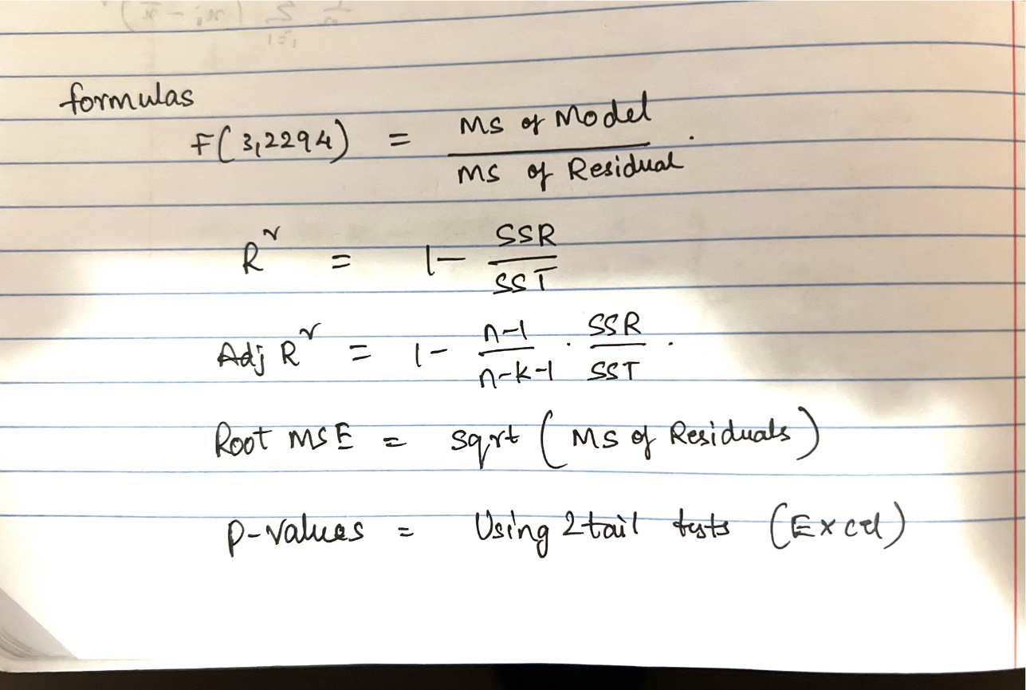

1. Interpret the Coefficients on ldist and bmktshr in English sentence

Coefficient of ldist(0.4544197) is the elasticity of lfare with respect to ldist

Coefficient of bmktshr(0.3092456) is the elasticity of lfare with respect to bmktshr

ldist: When ldist increases by 1%, lfare increases by 0.4544197%, holding all other independent variables fixed.

bmktshr: When bmktshr increases by 1%, lfare increases by 0.3092456%, holding all other independent variables fixed.

1. Test null hypothesis that the coefficient of bmktshr is equal to zero

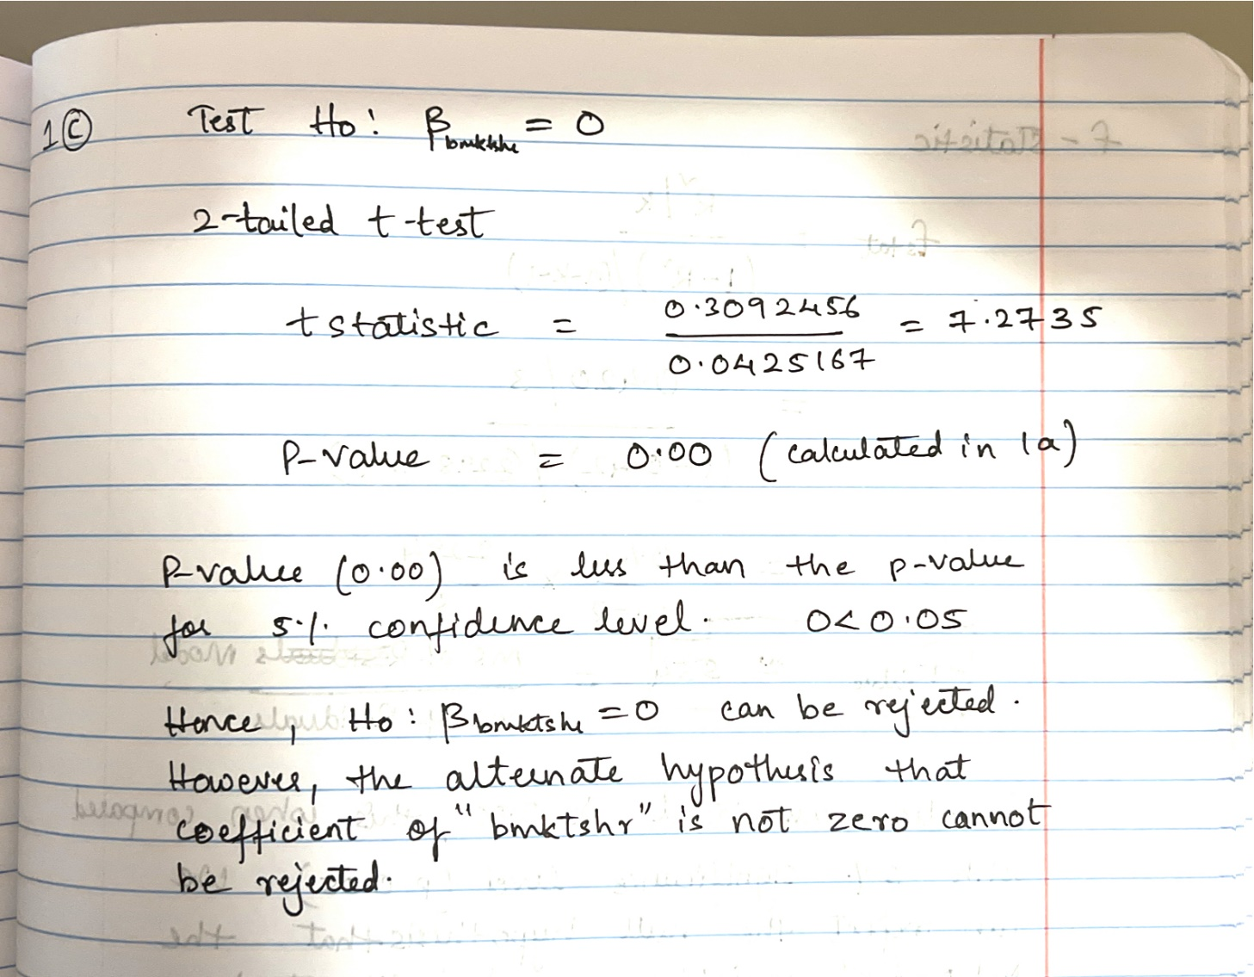

1. Interpret the R-squared and the overall F-statistic

R-squared

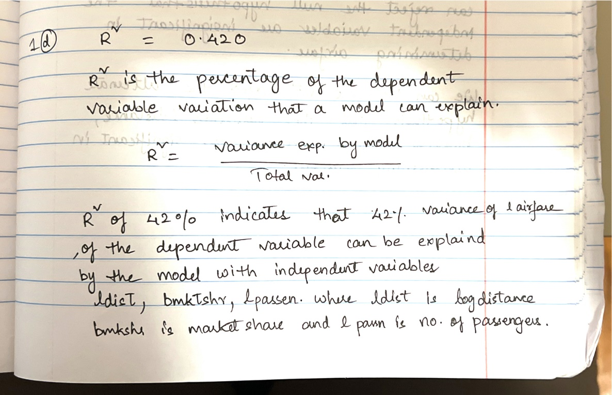

F-statistic

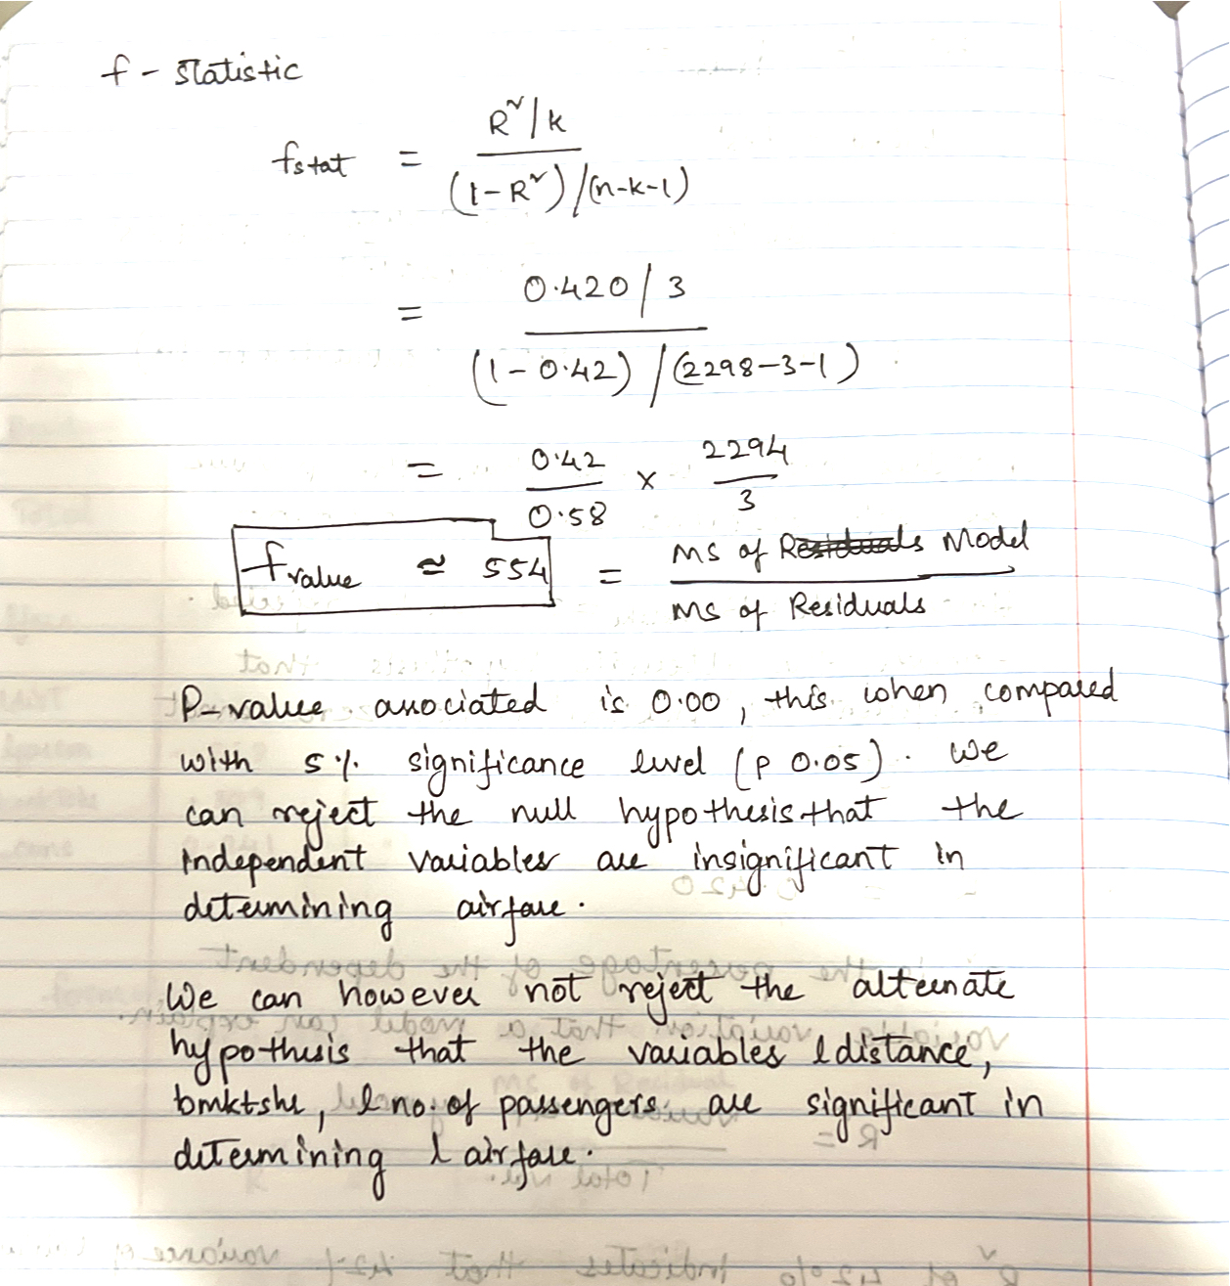

Question 2

1. First, test the hypothesis that 𝑯𝟎: 𝜷𝜷𝟎 = 𝟎 against the two-sided alternative. Then test   
   𝑯𝟎: 𝜷1 = 𝟏 against the two-sided alternative. What do you conclude?

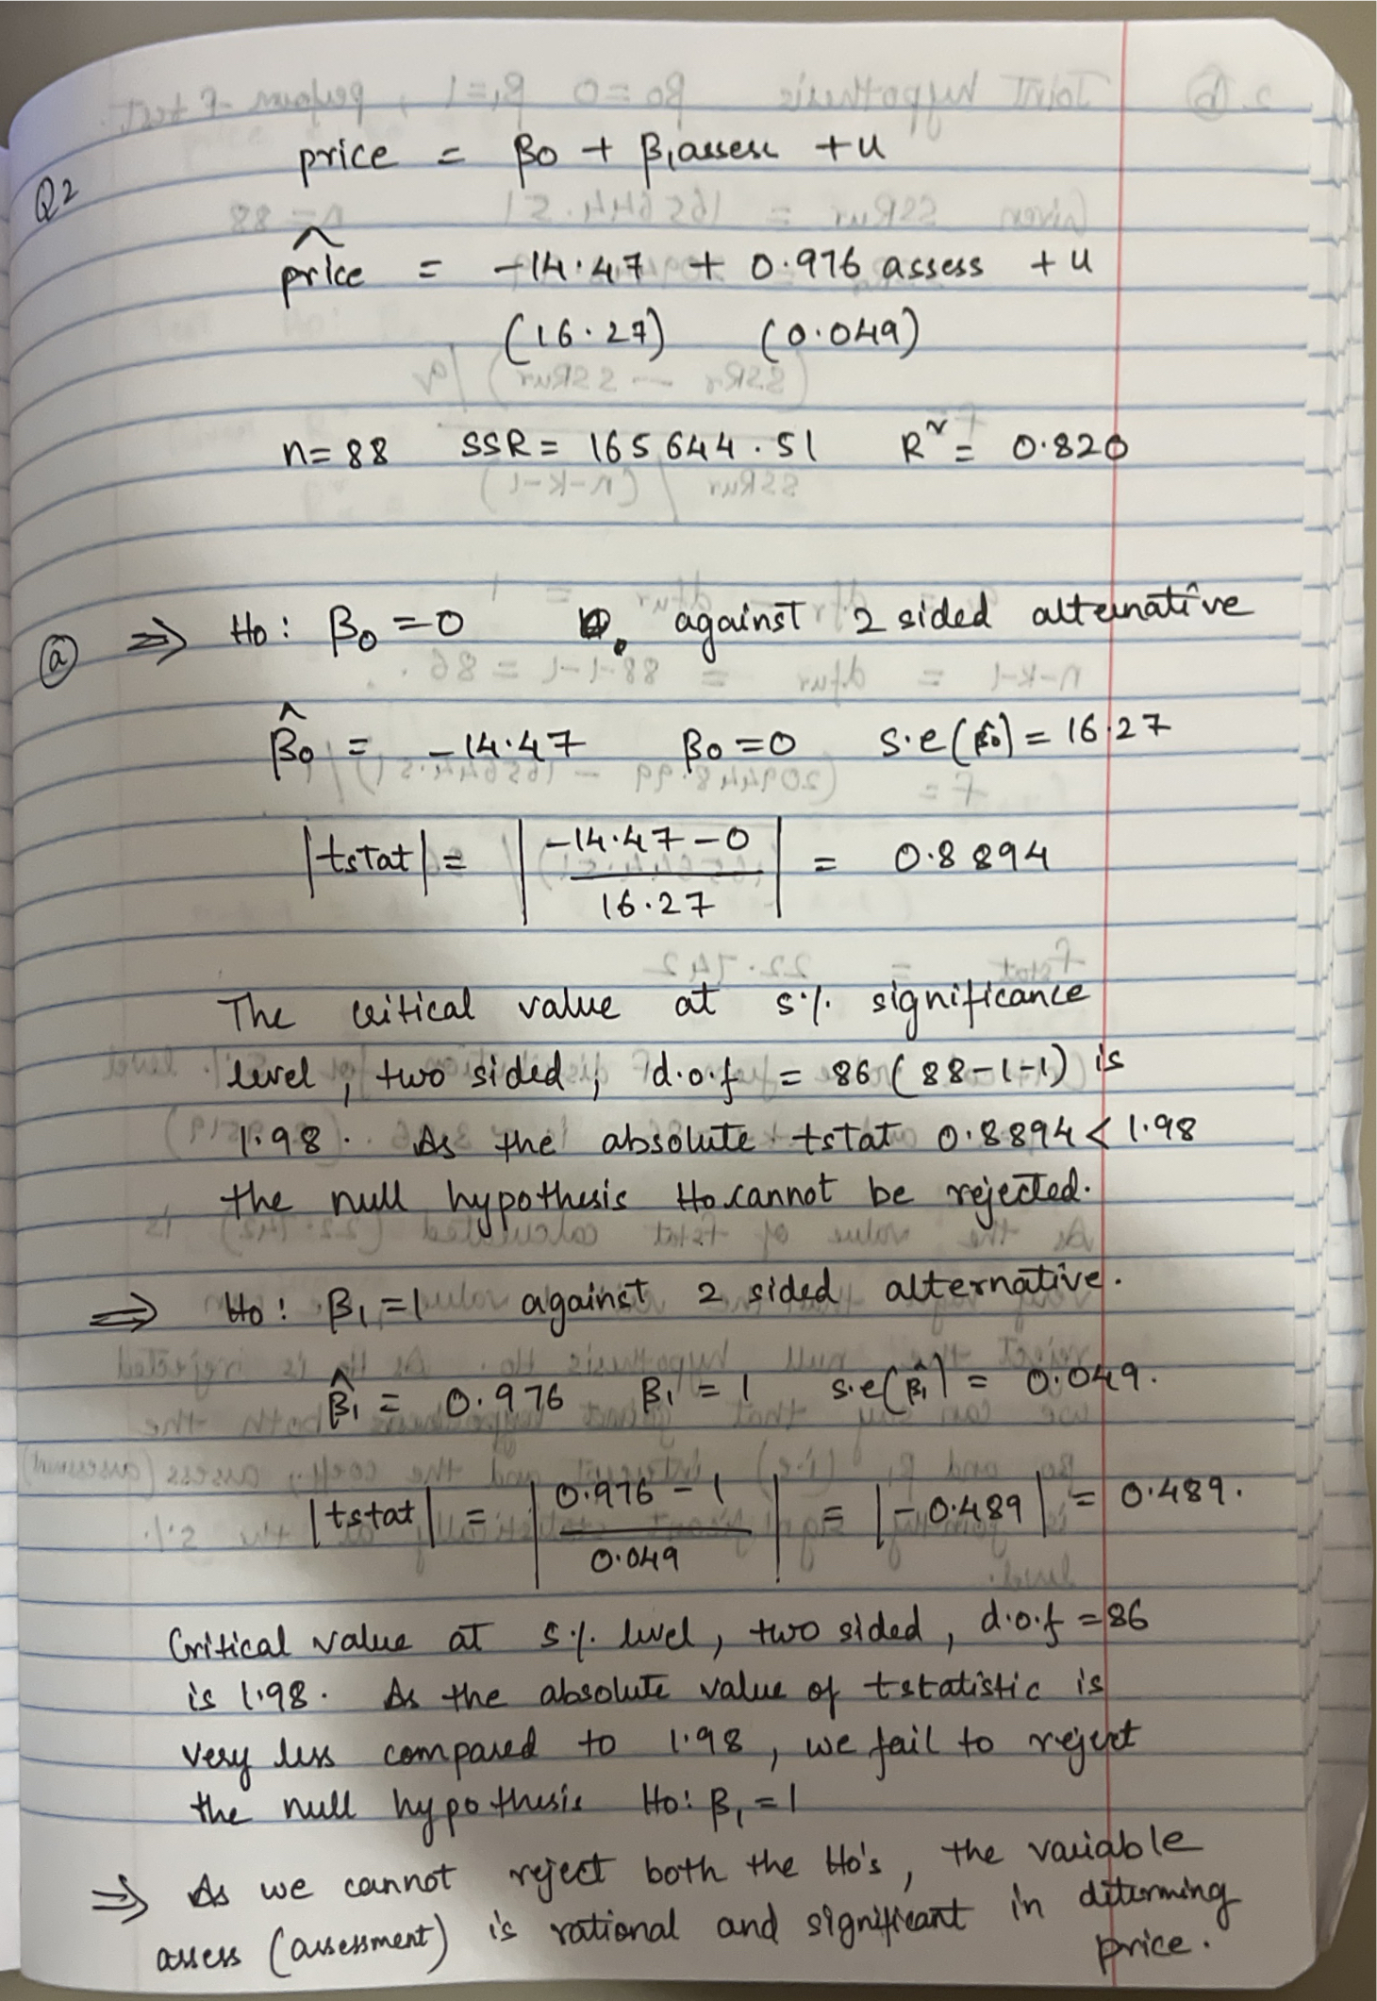

1. Joint hypothesis, B0 = 0 and B1 = 1

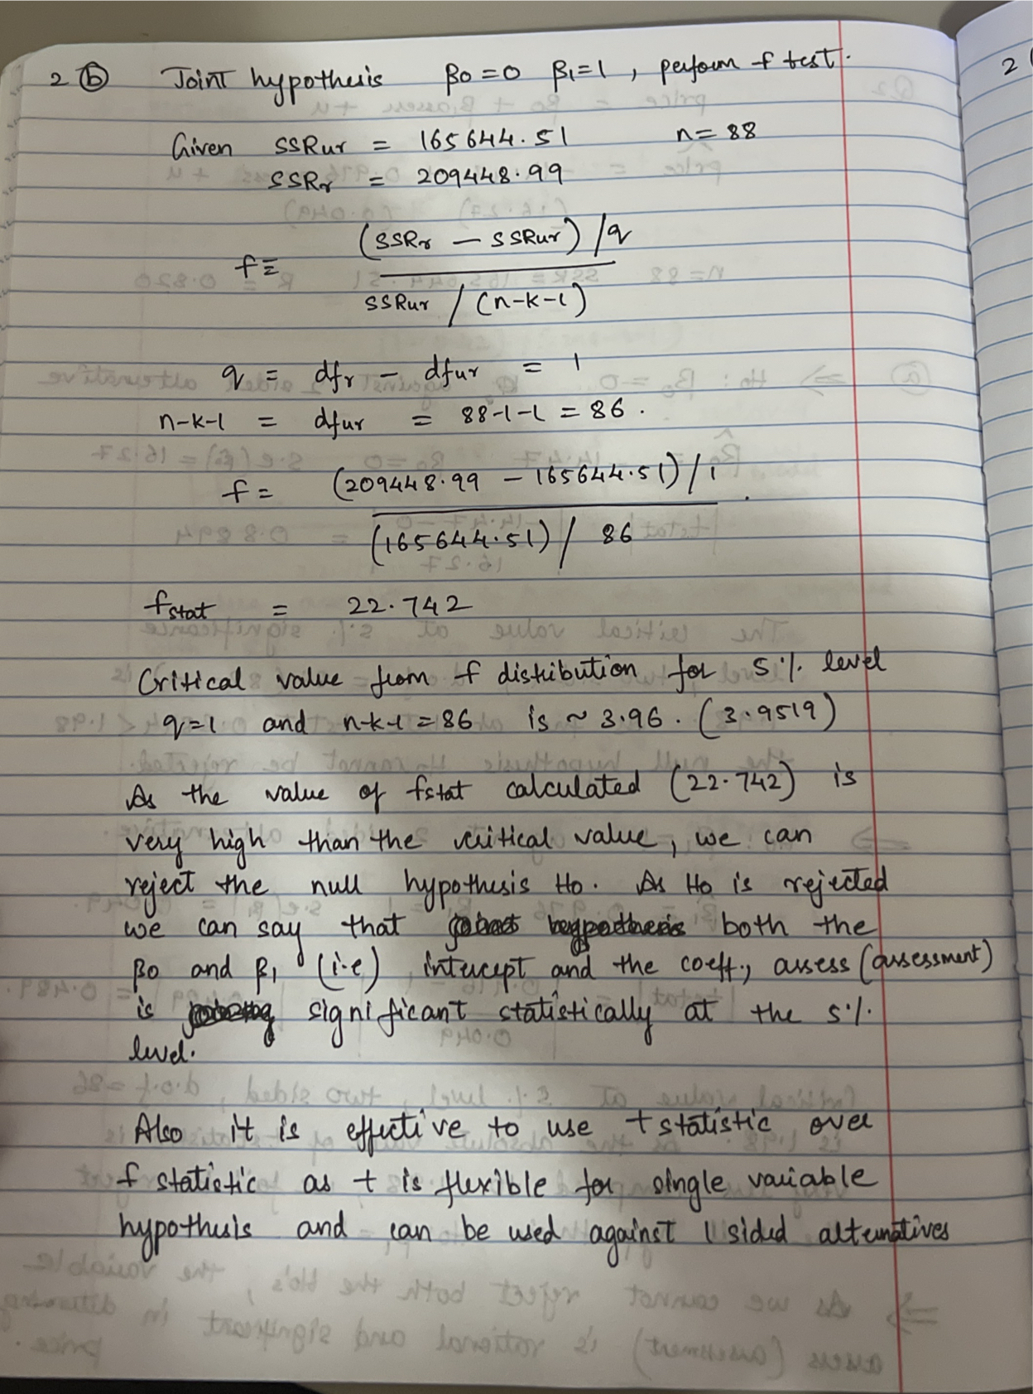

1. Test H0: B2 = 0 , B3 = 0, B4 = 0

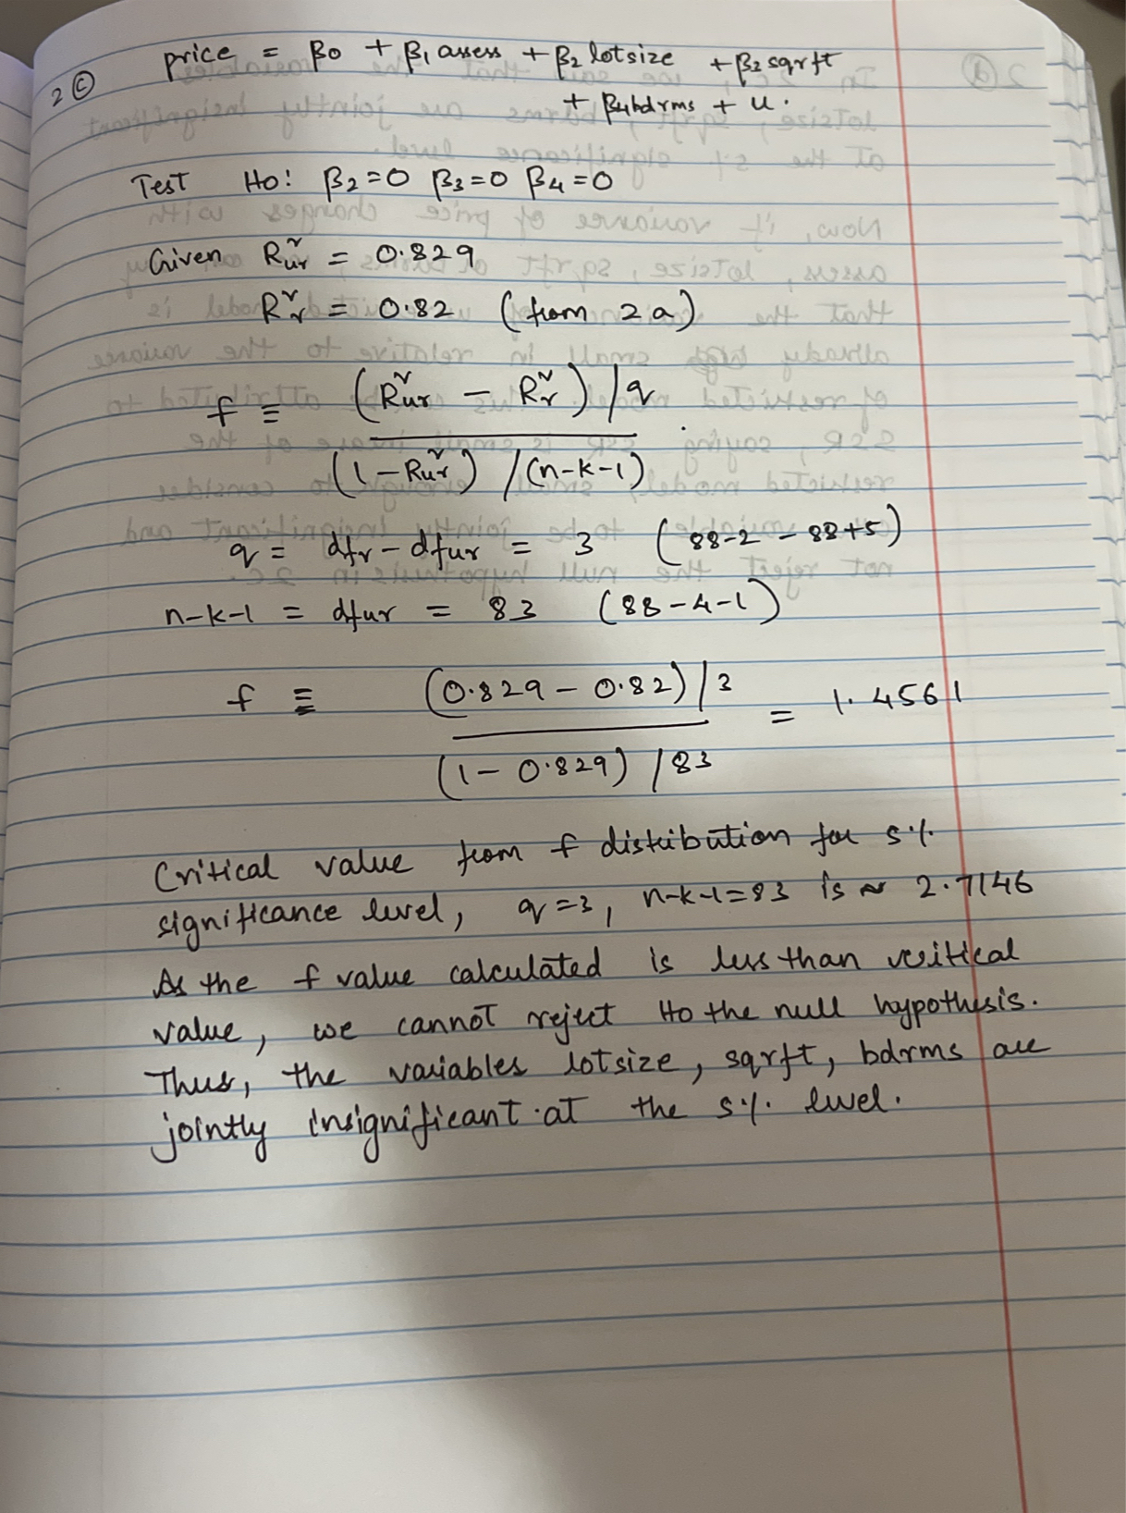

1. If the variance of price changes with assess, lotsize, sqrft, or bdrms, what can you say   
   about the F-test from part (c)

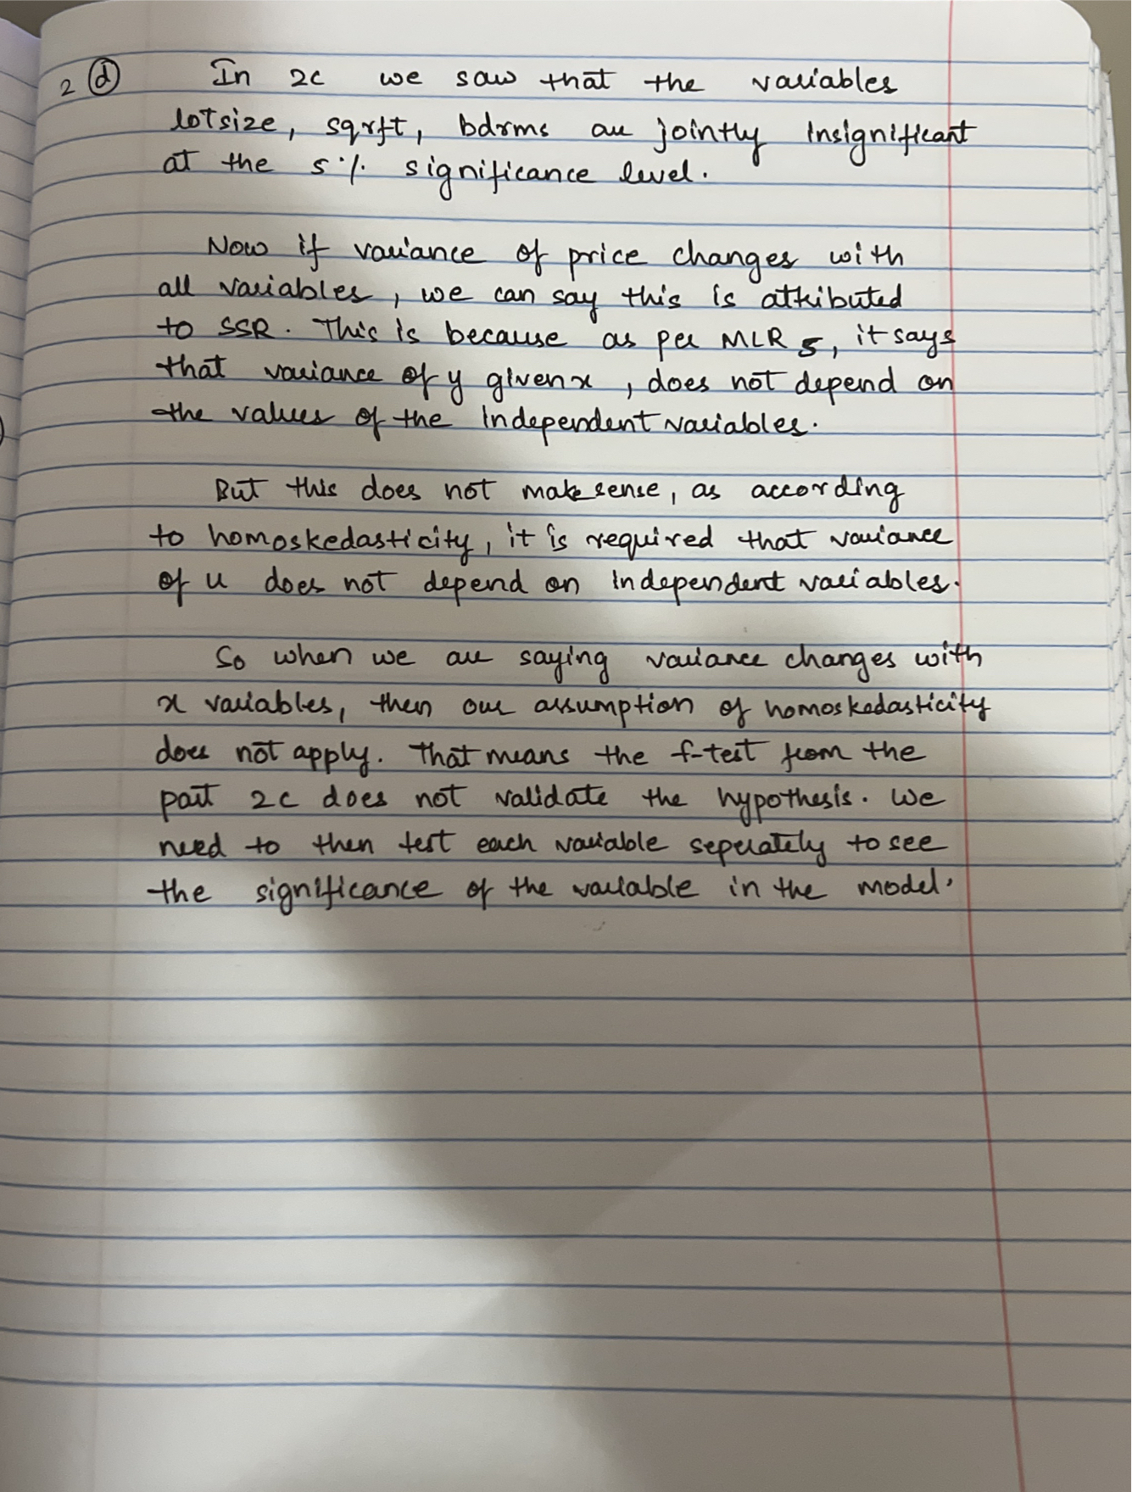

Question 3

1. Question 3a

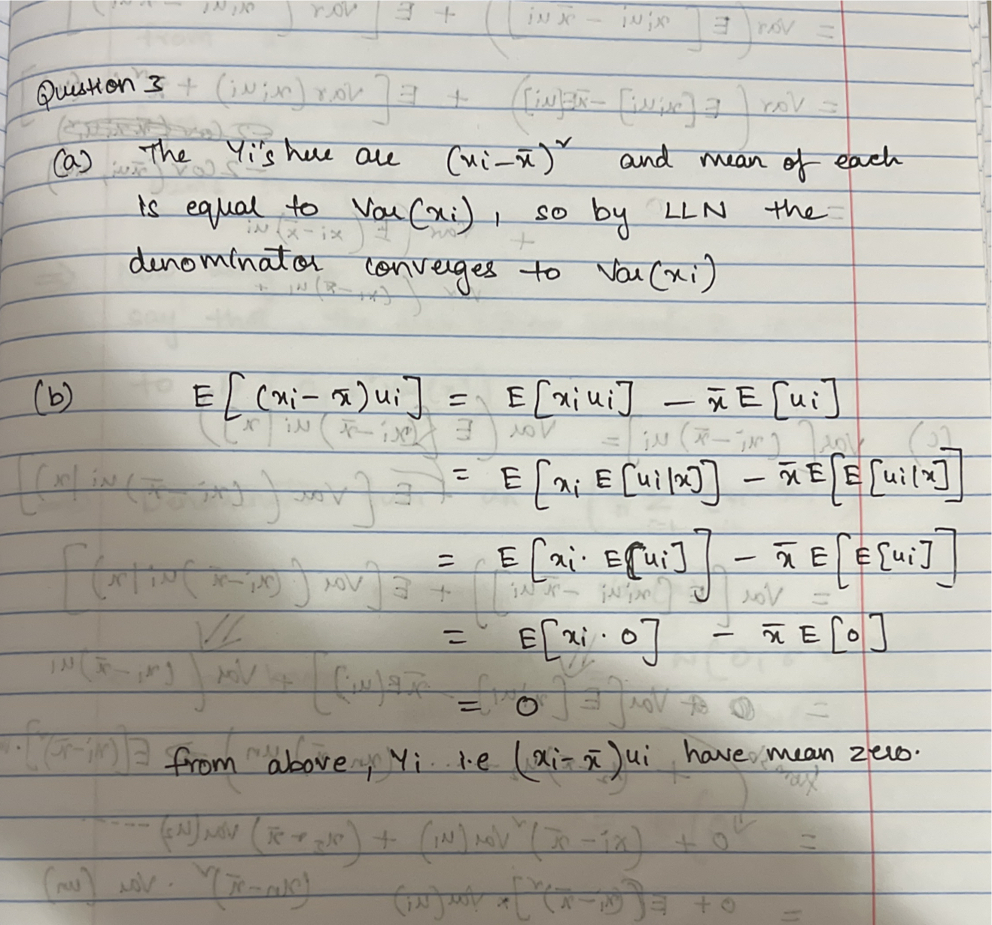

1. 3b

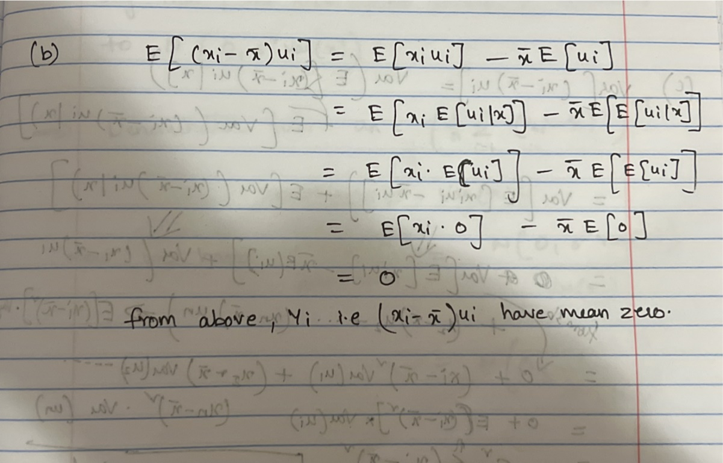

1. 3c

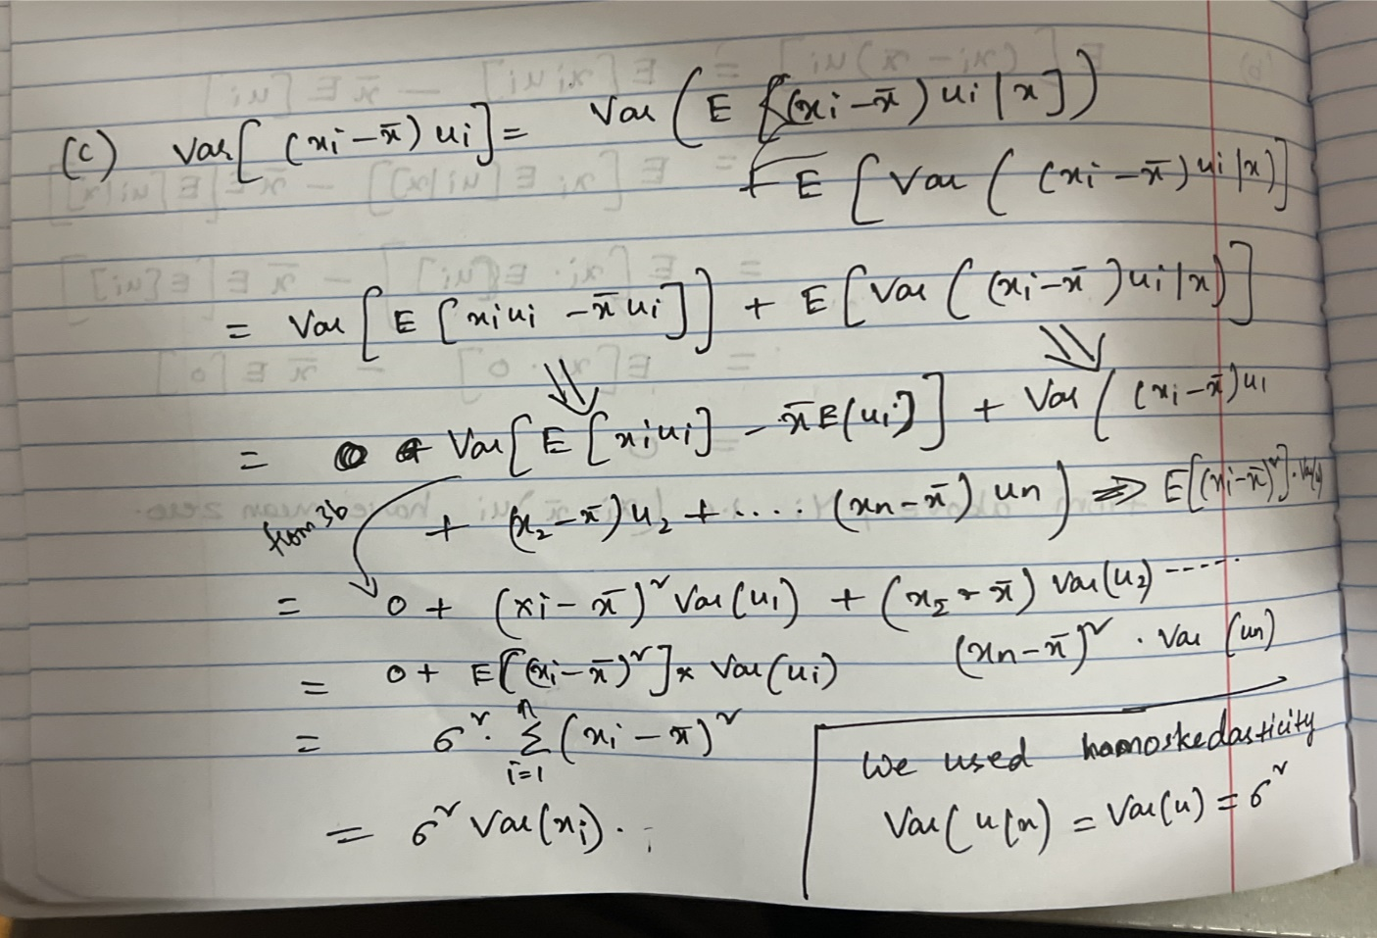

1. 3d

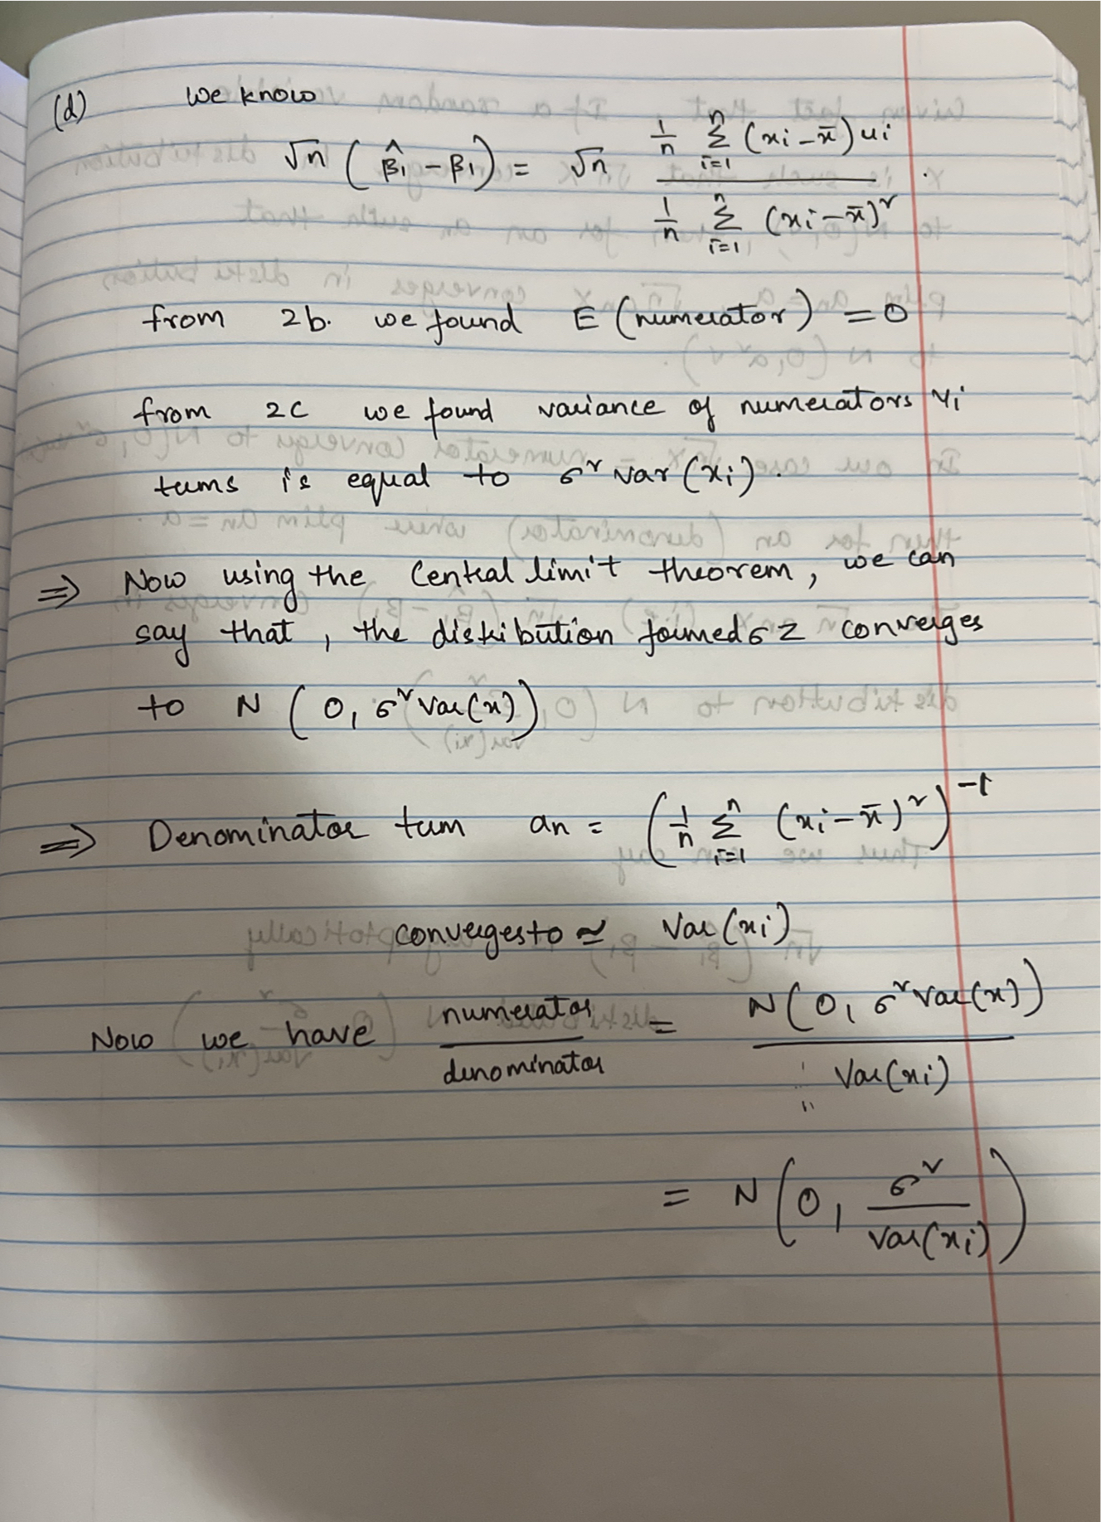

Continued…

